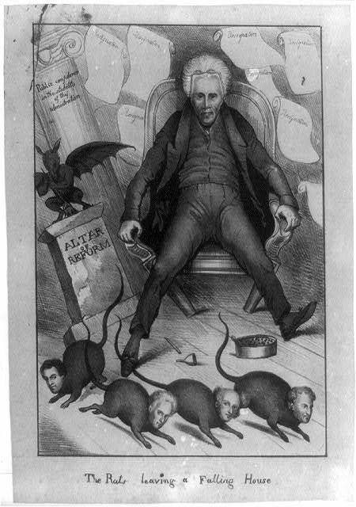
In this cartoon, Jackson is sprawled in a collapsing chair next to a falling column saying "altar of reform" where a winged jackass stands on it's hind legs holding a broom. In the background are nine resignation documents. The heads of the fleeing rats represent cabinet members, from left to right: Secretary of War John H. Eaton, Secretary of the Navy John Branch, Secretary of State Martin Van Buren (whom Jackson is trying to restrain by stepping on his tail) and Secretary of the Treasury Samuel D. Ingham. Jackson had a great deal of corruption in his administration, and many of his appointments had to resign in disgrace.
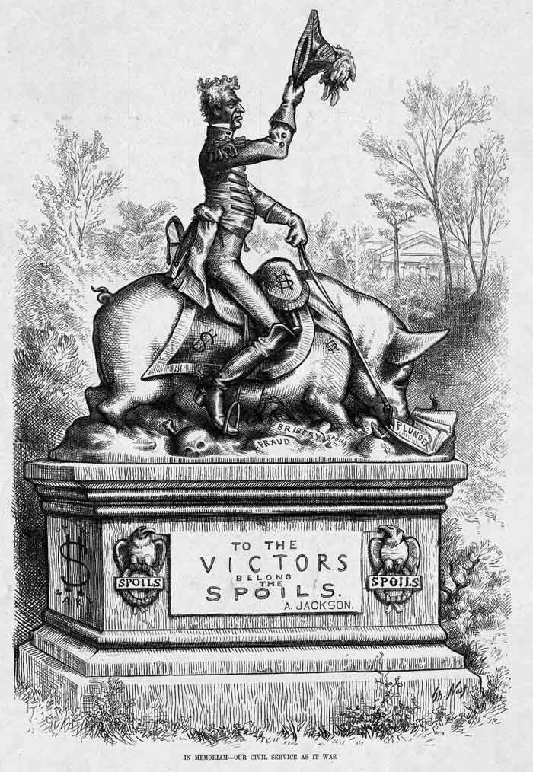
Jackson’s motto seemed to be "To the victor belong the spoils," and he certainly employed the "spoils system".One of his first acts was to fire dozens of federal employees, some who had been there since the days of George Washington. In their place he appointed people who had supported him.These appointments did not always work out so well. One member had to quit after having a well publicized affair.
The words, “fraud, bribery, and plunder” are seen underneath the pig. A skeleton is also seen under the pig, and the pig has dollar signs on it.
Thomas Nast drew the cartoon in 1877, when he was battling machine politicians in New York City who in his view had proved how corrupt the patronage principle “to the victors belong the spoils” really was.

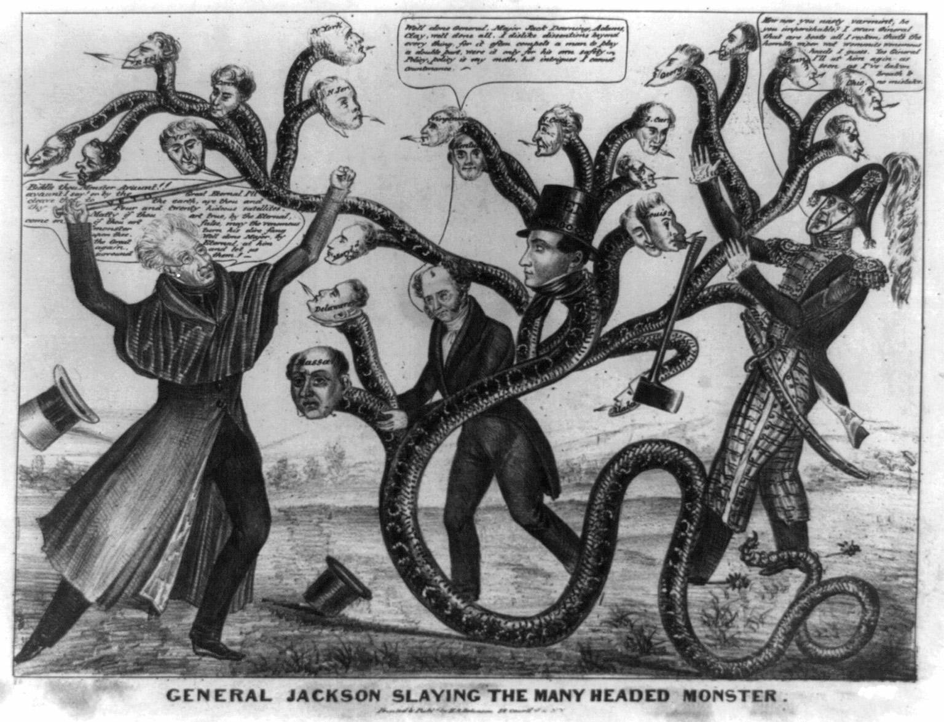
Andrew Jackson hated the idea of the Bank of the United States. He thought it wasn’t fair to the poor people. He wanted to destroy it. The many-headed monster is the states, who are fighting Jackson to keep the bank. Jackson raises a cane that says “veto.”
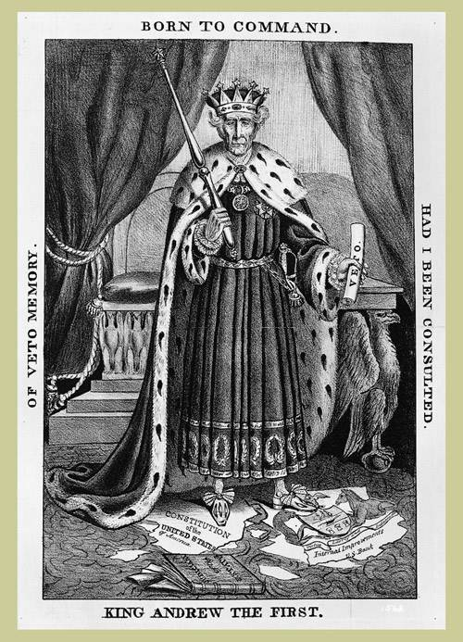
After his veto of the Bank of United States bill, President Andrew Jackson's opponents accused him of abusing his Presidential powers. This cartoon shows Jackson as a tyrannical king, trampling on the Constitution.

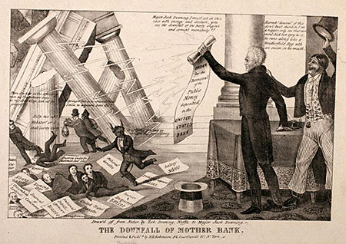
In 1832, as the expiration of the bank's 20-year charter approached, bank president Nicholas Biddle took a political gamble: believing that Jackson could ill-afford to destroy the bank, Biddle decided to apply early for the charter's re-newal. Biddle's gamble, however, backfired; Jackson's vetoed the charter, the bank collapsed, and the American economy went into depression.

In this cartoon, Jackson's is seen holding the "Order to Remove the Public Money deposited in the UNITED STATES BANK." Next to him is the fictitious political commentator, Major Jack Downing, cheering Jackson on. Jackson says to Downing, "Major Jack Downing. I must act in this case with energy and decision, you see the downfall of the party engine and corrupt monopoly!" For his part, Downing replies, "Hurrah! General! If this don't beat skunkin', I'm a n-----, only see that varmint Nick how spry he is, he runs along like a Weatherfield Hog with an onion in his mouth."

From the order come lightning bolts which topple the columns of the Bank, and small individuals - bankers - are seen running away in terror. Around them are strewn various newspaper and sheet with "Salary $6,000" and "Printing expenses $80,000" Bank president Nicholas Biddle - assuming the qualities of a demon - exclaims, "It is time for me to resign my presidency."

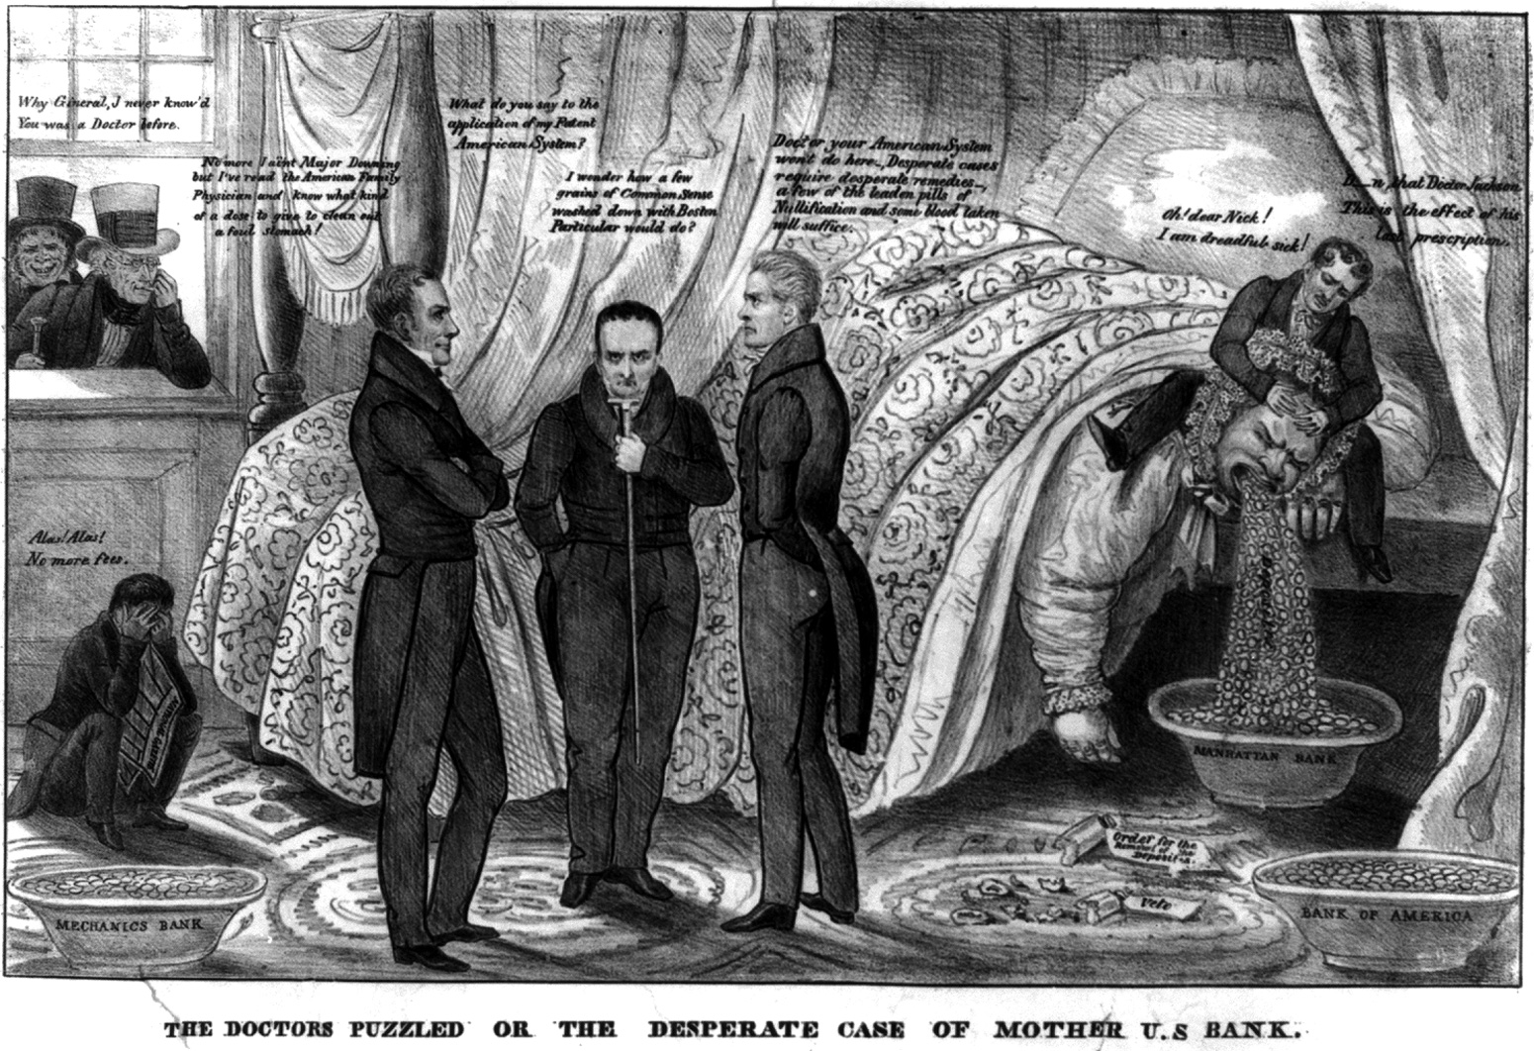
Summary: A satire directed against the United States Bank, showing the impact of Jackson's September 1833 order for the withdrawal of federal funds from the Bank and their distribution among state banks. In a bedchamber the Bank, portrayed as an obese woman, lies in bed vomiting coins "Deposites [sic]" into a basin "Manhattan Bank." Nearby are two other basins (filled) marked "Mechanics Bank" and "Bank of America," and two broken medicine vials labeled "Veto" and "Order for the Removal of the Deposites." Bank president Nicholas Biddle holds her head. Bank: "Oh! dear Nick! I am dreadful sick!" Biddle: "D--n that Doctor Jackson. This is the effect of his last prescription." At left stand Bank supporters Henry Clay, Daniel Webster and John Calhoun, as physicians in consultation. Clay: "What do you say to the application of my Patent American System?" Calhoun: "Doctor your American System won't do here. Desperate cases require desperate remedies, a few of the leaden pills of Nullification and some blood taken will suffice." Calhoun's reputation in the North was sorely affected by his leadership role in the southern Nullification effort of 1832. Webster (in the center): "I wonder how a few grains of Common Sense washed down with Boston Particular would do?" On the floor at left sits a man, no doubt a pro-Bank newspaper editor, holding a copy of the "National Gazette," moaning: "Alas! Alas! No more fees." Jackson and Major Jack Downing look in through a window at far left. Downing: "Why Gineral, I never know'd You was a Doctor before." Jackson: "No more I ain't Major Downing but I've read the American Family Physician and know what kind of a dose to give to clean out a foul stomach!"

